**TO FIND ARTICLES AT CCAC’S ONLINE LIBRARY**

* Click the Start button, and Click on Internet Explorer (or the Browser that you are using).

You can also find the internet browser on the desktop, taskbar, as well as through the start, all programs, Internet Explorer.

* At the Address bar, type in [www.ccac.edu/library](http://www.ccac.edu/library) and press the enter key

Your screen should look similar to Figure One.

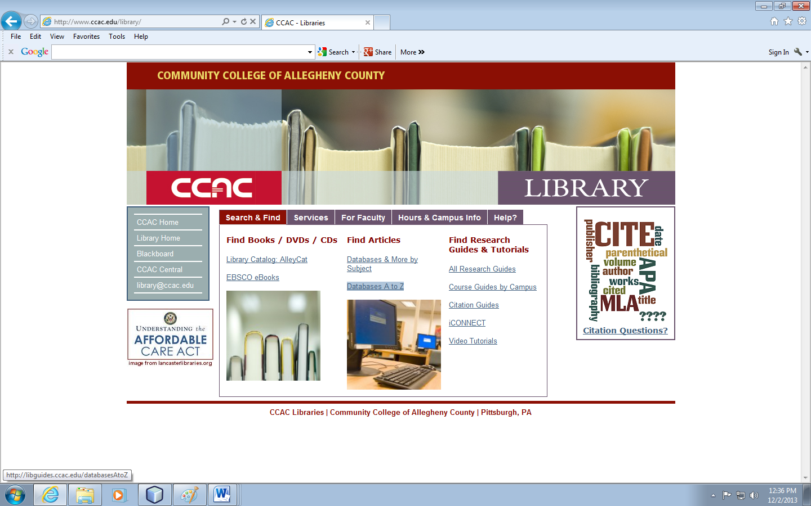

Figure One

Article Databases

Address Bar

* Choose Databases A to Z
* Login in with your CCAC Username and Password (if you are not on campus) and click the Login button. Your screen should look similar to Figure Two.

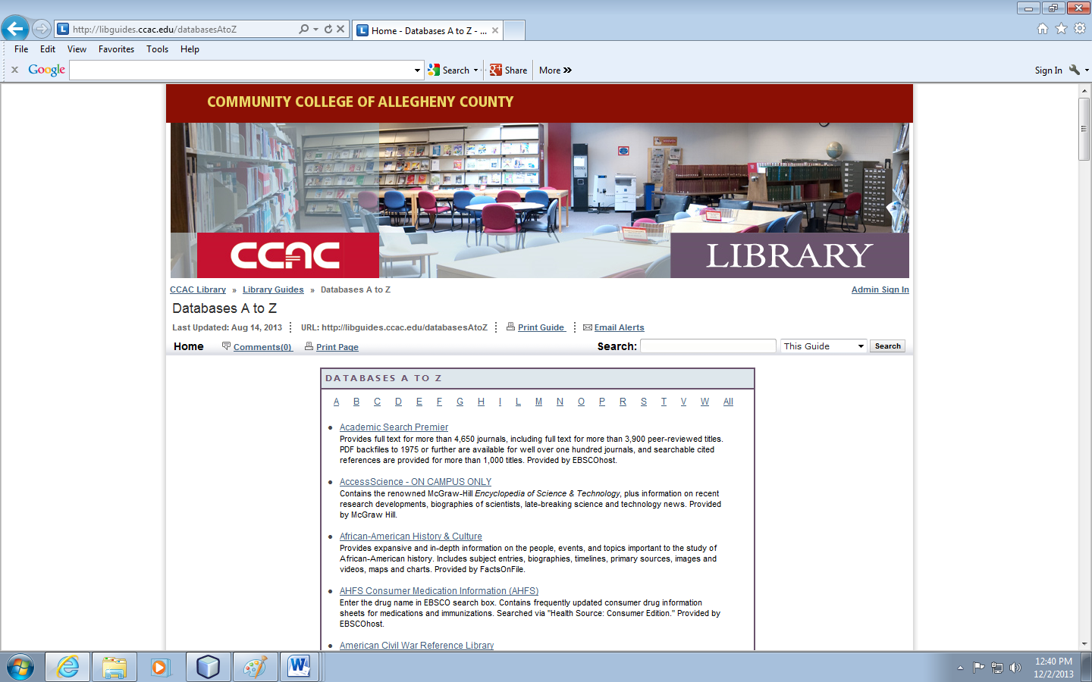

Databases to choose from

Figure Two

* Click the Academic Search Premier Database. Your screen should be similar to Figure Three

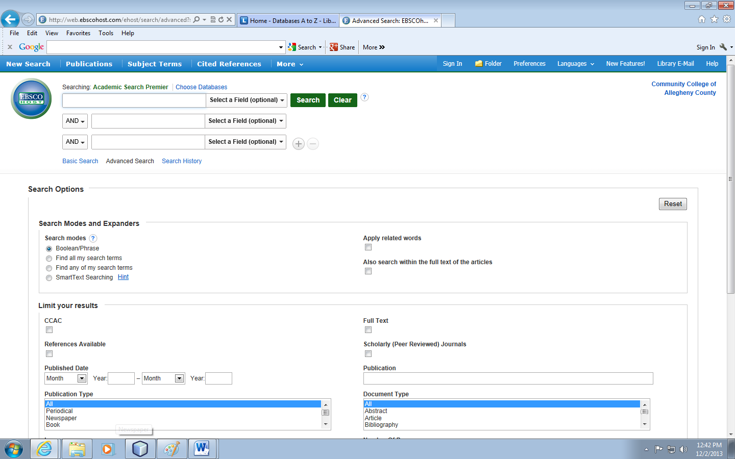

Click the Full Text check box

Enter Keyword

Enter Keyword

Figure Three

* Type in your keyword searches, click the Full Text check box (in order to see the articles) and click the Search Button.

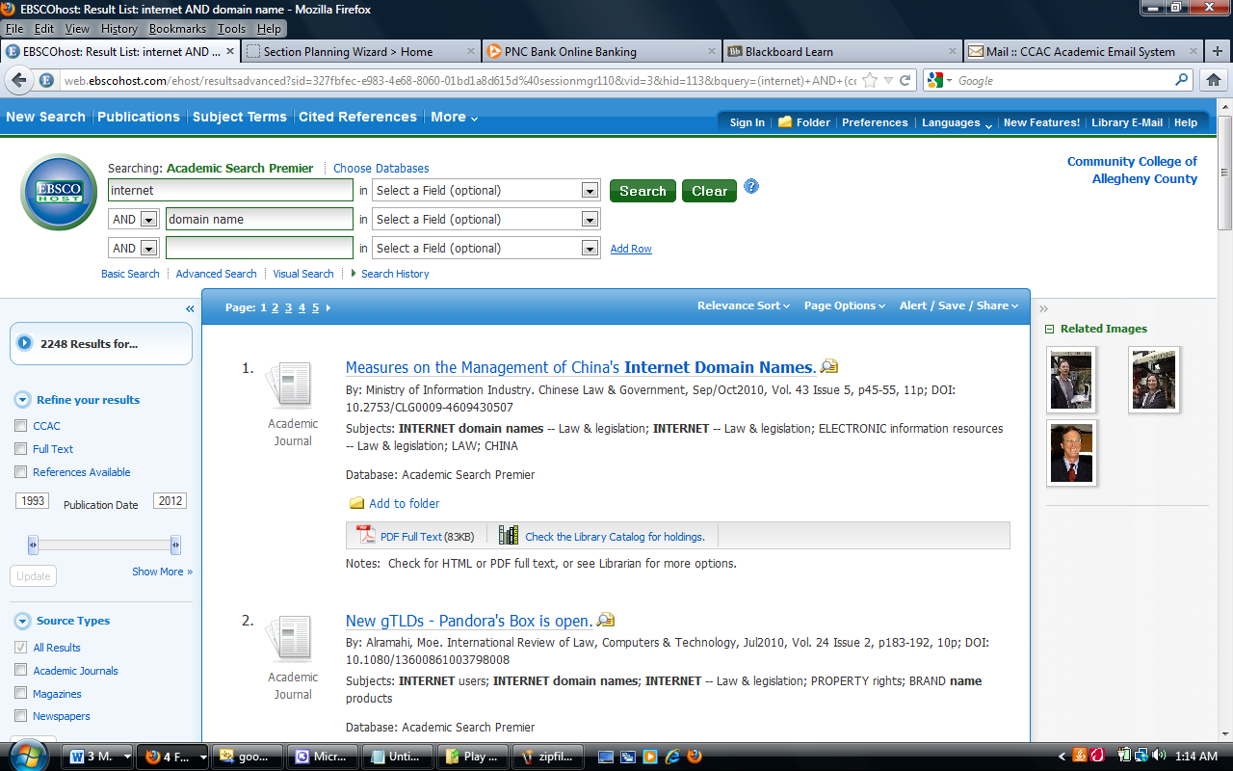

PDF Format

Figure Four

Once you type in your keyword searches and press the Search button, you should see a listing of articles written on the subject (see Figure Four). The articles will be listed in terms of reference information, as well as the formats for the article. The article formats can be in PDF (Portable Document Format) or HTML (Hypertext Markup Language).

Choose the format (PDF is a better format for it actually shows the article as it would be in print) in which you want to view the article (see Figure Five)

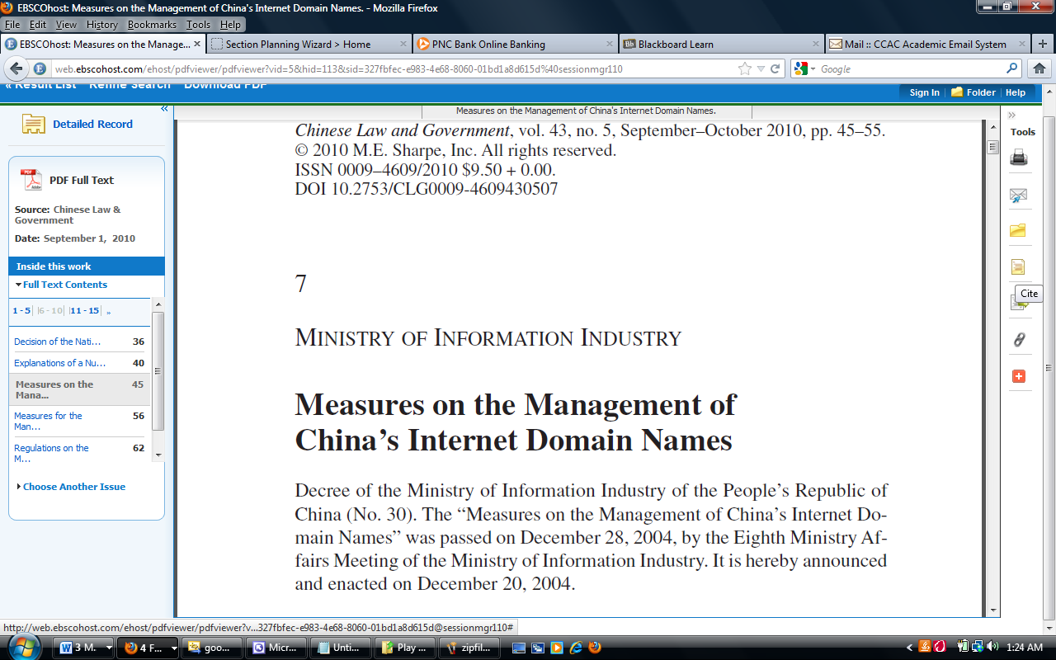

Tools

Figure Five

Once you review the article and it is one that you want to use, you can use the Tools to print, e-mail, as well as cite the article. Using the Cite menu will show you the reference in various formats (See Figure Six).

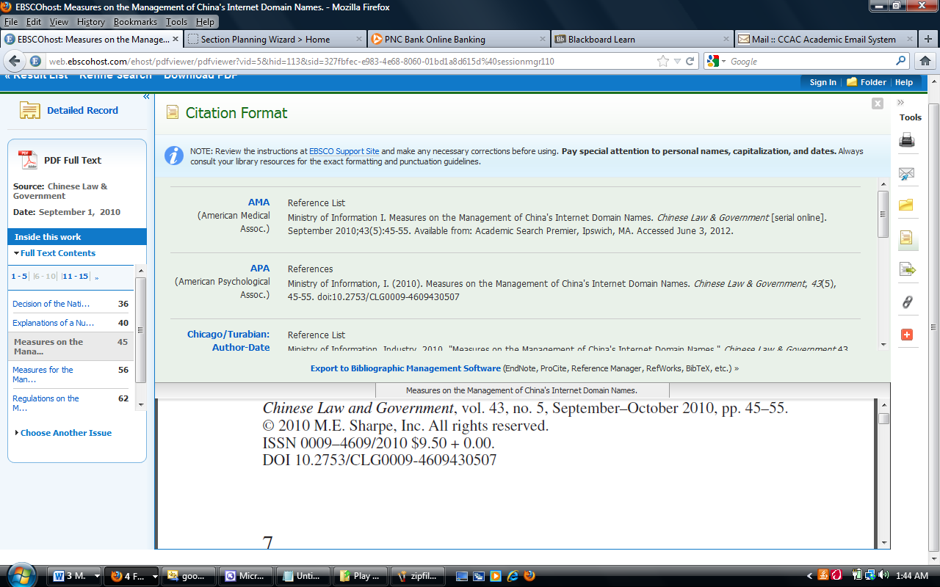

Figure Six

Again, if it is an article you want to use, you can highlight the reference material (there are different formats to choose from: AMA, APA) and then use right-click and copy to copy the reference, and then click on the application where you want to paste the reference and then right-click and choose paste. Clicking the Cite button again will remove the reference list in which to view the article.

You can then repeat this process to find additional articles on a variety of articles.